STOCK MARKET CHARTING

MILESTONE 4

EMP ID: 761412

NAME: Kshitij Kaushal

GITHUB LINK: https://github.com/kshtz25/StockMarketPostman/

Description:

This based on rest api no UI .

Use postman to check all microservices.

INSERT COMPANY DETAILS

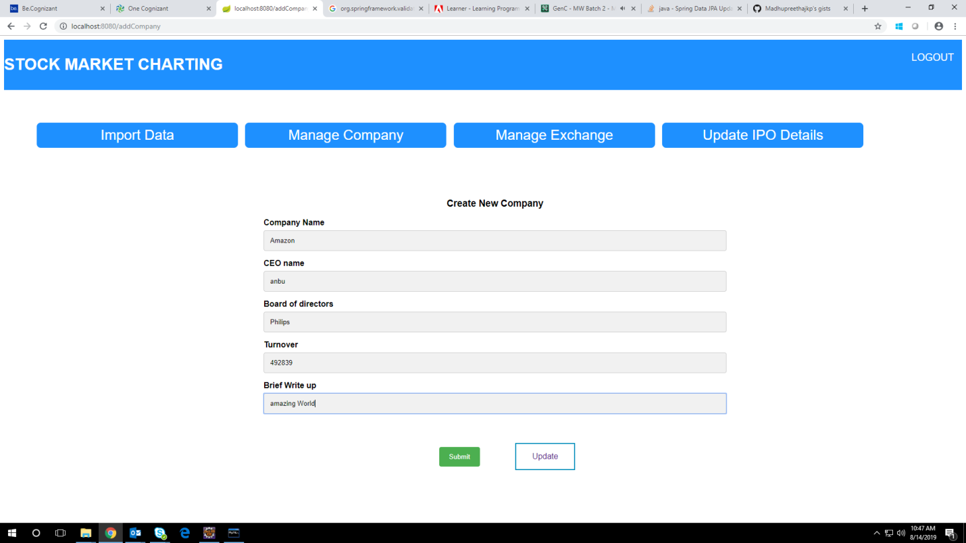

LIST COMPANY DETAILS

